The Grampian Engagement Network (GEN)
Developing a Hallmark for Engagement in Grampian

By Liz Howarth
Consultation and Engagement Advisor
NHS Grampian

Contents

The Grampian Engagement Network – Background………….. Page 3
The Engagement Hallmark for Grampian………………………… Page 4
The Grampian Engagement Network – Training Record……… Page 6
Approaches to Engagement…………………………………….... Page 7
Further Reading……………………………………………………. Page 11

The Grampian Engagement Network (GEN)
Background
The Grampian Engagement Network (GEN) began as an idea to co-design a hallmark for great practice in engagement. This process began in November 2020 with a core group of about 10 members from across the sectors, including a Public Representative. At this time, the country was in lockdown due to Covid-19.
People working in engagement roles in Grampian subsequently found themselves trying to do engagement with people and communities at a time when everyone was learning to live and work in isolation.
During the course of the process, the Network gathered interest and increased its membership significantly, as people felt a desire to connect and collaborate with others who found themselves in a similar situation experiencing a collective challenge.
By the time the first draft of the Hallmark for Engagement had gone out for consultation in August 2021, the Network had grown to consist of around 40 members of engagement practitioners from all sectors in Grampian, including
- NHS Grampian
- Health and Social Care Partnerships
- Third Sector
- Public Representatives
- Community Planning
- Local Authority
Consultation regarding the future of the GEN is currently underway to co-design the future of the Network, including the role and function it will have in supporting future engagement in Grampian.
Many thanks to everyone who has supported and participated in this process.
Further information can be found in the embedded document, taken from a feedback session held on 12th July 202

The Grampian Engagement Network (GEN)
Hallmark for Engagement – 10 considerations
The Hallmark for Engagement was co-created by the Grampian Engagement Network (GEN) as part of a specific piece of work which took place from November 2020 – August 21. During this time the GEN undertook a programme of training and investigation to explore the key approaches to engagement, namely
- Scottish Approach to Service Design (SAtSD)
- National Standards for Community Engagement
- Planning with People.
The following 10 considerations are the culmination of this work, based upon analysis and theming of the discussions that took place.
The below is intended to be used as a benchmark for good quality engagement and covers both values and approaches.
For a practical guide to good quality engagement please use the National Standards for Community Engagement which can be found by clicking here.
- Planning
Good planning is vital, particularly having clarity on the purpose for your engagement and what level of engagement you are undertaking (informing, consulting, co-producing). To plan effectively you can use a tool like VOiCE which can be found by clicking here.

- Identifying and appreciating resources
Before you begin to engage, it’s important to identify that you have sufficient resources, this could include staff and community capacity, money, time, people, space, etc. Your aspirations for engagement should be proportionate to the resources you have available. It’s important not just to identify resources but to also appreciate them – this will help to build trust and relationships.

- Being inclusive
Inclusion and equality should be at the heart of any good engagement. Think about how any barriers to engagement can be overcome so that access is as equal as possible.

- Fostering ownership
Engagement is at its best when as many people as possible commit to and own it. This is at all levels within and across organisations and partnerships. Understanding is a key part of ownership so it’s important to build knowledge about engagement, including at senior levels where decisions are more likely to be made.

- Building on previous engagements
It’s essential to review the findings from previous relevant engagements – what you need to know may already have been fully, or partially, established by previous work. This has three key benefits – it shows you are valuing things the community have already told you; it can avoid over-consultation; it can help to develop ongoing engagement and relationships.

- Being aspirational
This may be about pushing boundaries, embracing new ways of engaging such as online or engaging with people you haven’t previously. Trying new things generally improves the quality of your engagement work over a period of time.

- Working and learning together
Collaboration is essential to ensure that individual engagements take account of and add value to each other. This co-production approach will help to avoid unnecessary repetition and consultation fatigue. Also vital here is valuing lived experience equally to professional experience.

- Building trust and relationships
This is the best way to achieve meaningful, ongoing dialogue. Being open and honest is key e.g., your motivations for engagement; what can be influenced by the engagement, and importantly, what can’t. What other factors, alongside the learning from engagement, will influence final decisions; what resources are available.

- Making engagement a worthwhile experience for participants
This isn’t about how engagement has influenced decisions. It’s trying to ensure that the act of engagement has been positive e.g., felt enjoyable, building on and sharing skills; meeting new people; being interested; having fun; being empowered.
- Closing the loop

This emphasises the importance of feeding back to participants, and the community more generally, what the outcomes and influence of the engagement have been, even if it is none. It also covers the importance of learning from the engagement activity – what worked well and what needs improved. This will allow you to build a base of evidence for what good quality engagement looks like for you, and will hopefully also ensure a welcome next time you need to ask for people’s views
Consultation Period - 30th August – 23rd September 21
Approved by the GEN on 23rd September 2021

Grampian Engagement Network (GEN)
Training | By who | Date | Presentation | Link to session | Summary notes
Scottish Approach to Service Design (SAtSD) | Ali Jones, Service Designer, Scottish Government | 26th November 2020
National Standards for Community Engagement | David Allan, Deputy Director, Scottish Community Development Centre (SCDC) | 7th May 2021 |  | To be added
Planning with People | Emma Ashman, Service Change Advisor and Chris Third, Engagement Officer, Health Improvement Scotland (HIS) | 12th July 2021 |  | To be added
Training Record
Developing an Engagement Hallmark for Grampian
‘Evolving Through Involving’

Principles of National Standards for Community Engagement

Principles of SAtSD
- We explore and define the problem before we design the solution.
- We design service journeys around people and not around how the public sector is organised.
- We seek citizen participation in our projects from day one.
- We use inclusive and accessible research and design methods so citizens can participate fully and meaningfully.
- We use the core set of tools and methods of the Scottish Approach to Service Design.
- We share and reuse user research insights, service patterns, and components wherever possible.
- We contribute to continually building the Scottish Approach to Service Design methods, tools, and community

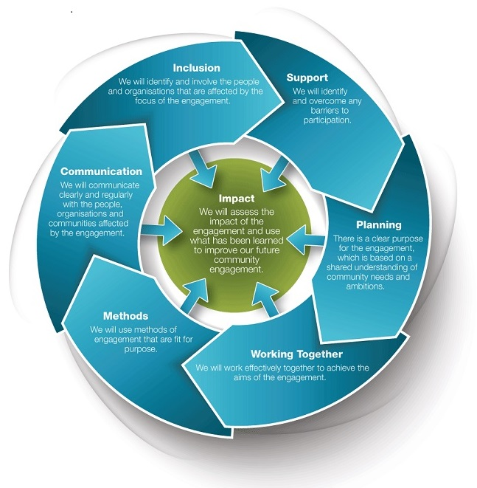
Other
National Quality Framework for Engagement
People Powered Health and Wellbeing

Planning with People
Identify the issue

Identify stakeholders who may be affected by the issue
Feedback

Plan engagement
Decision making

Engage those potentially affected
Evaluate engagement

Other approaches to consider include…
People Powered Health and Wellbeing

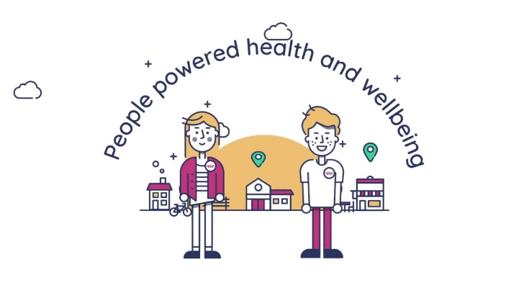
Quality Framework for Community Engagement

Coproduction Models

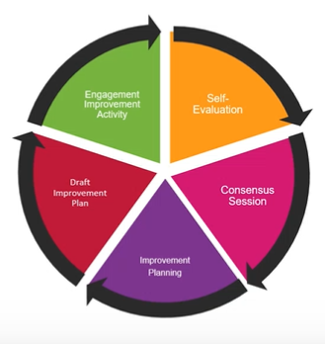

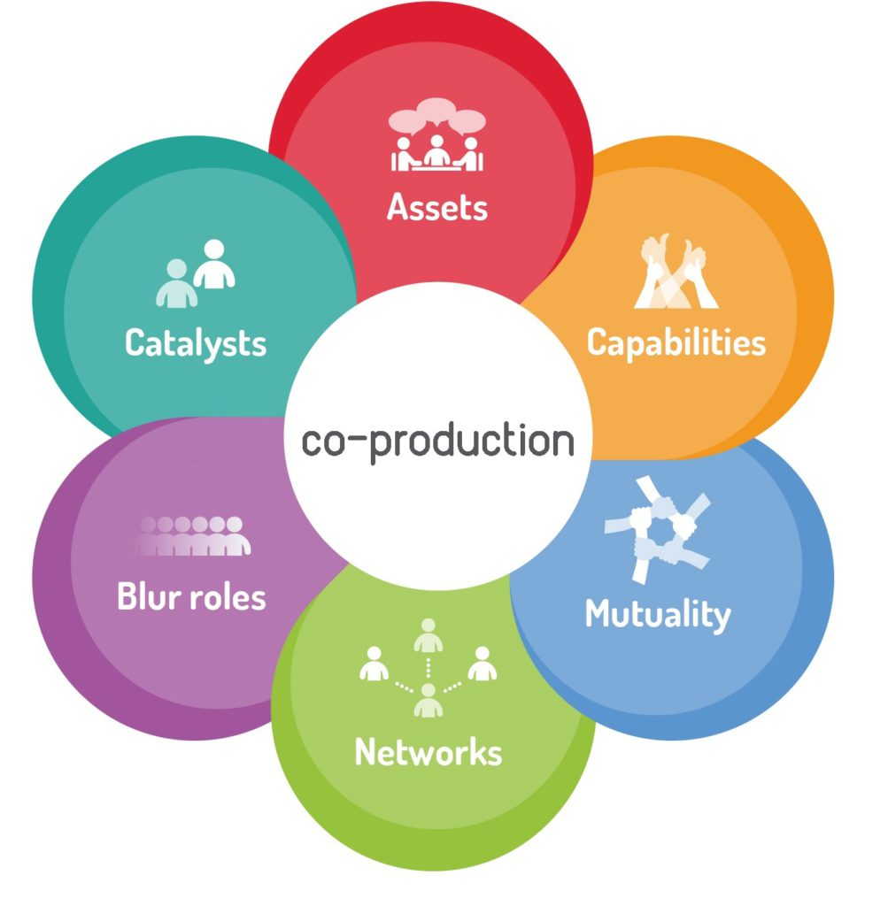
Asset Based Approach to Community Development (ABCD)
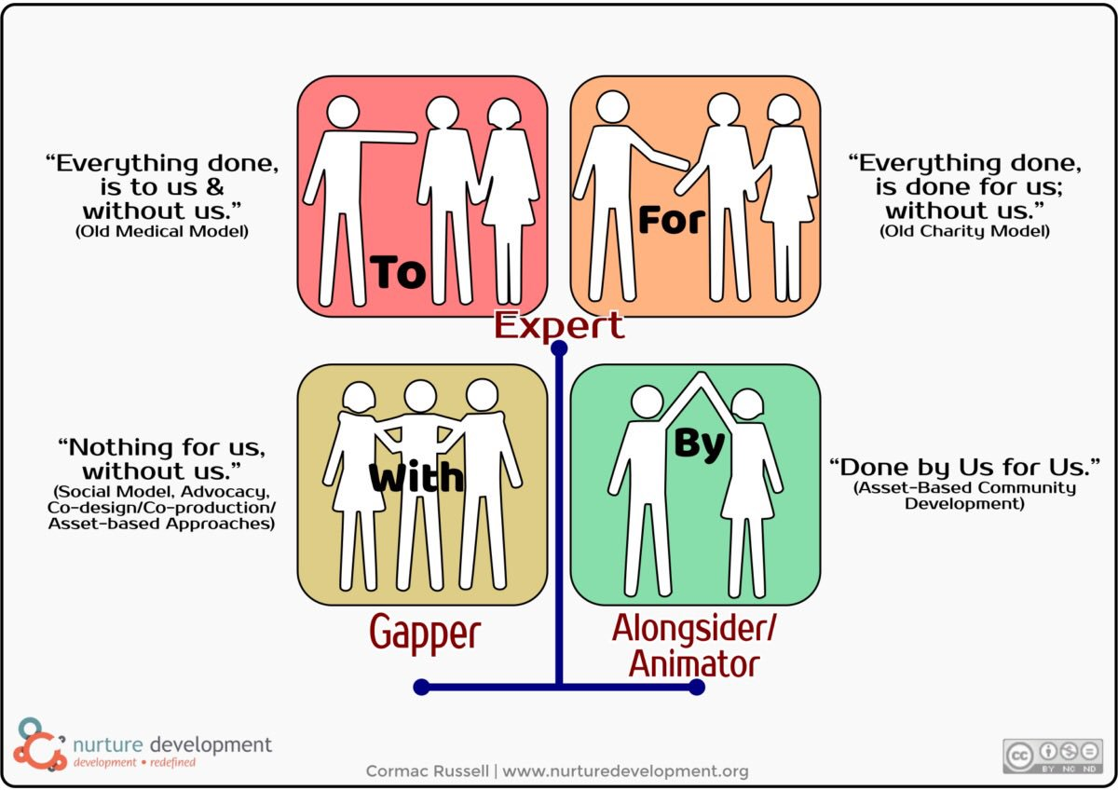

Further Reading

Topic | Key Organisation | Website | Key Documents
Scottish Approach to Service Design (SAtSD) | Scottish Government | The Scottish Approach to Service Design (SAtSD) - gov.scot (www.gov.scot)
National Standards for Community Engagement | Scottish Community Development Centre (SCDC) | National Standards for Community Engagement | SCDC - We believe communities matter
Planning with People | Scottish Government | Care services - planning with people: guidance - gov.scot (www.gov.scot)
People Powered Health and Wellbeing | Scottish Co-production Network  Nesta | People powered health and wellbeing — Scottish Co-production Network (coproductionscotland.org.uk)  People Powered Health Programme | Nesta
Asset Based Approach to Community Development | Nurture Development | ABCD Training and Resources - Nurture Development
Coproduction | Scottish Co-production Network | Scottish Co-production Network (coproductionscotland.org.uk)
Public and Patient Participation Policy – with particular focus on p7 | NHS England | NHS England Public Participation Policy.pdf

